Output

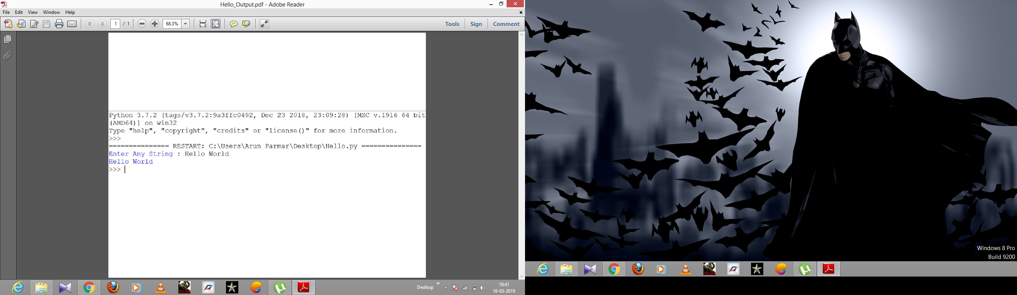

Output

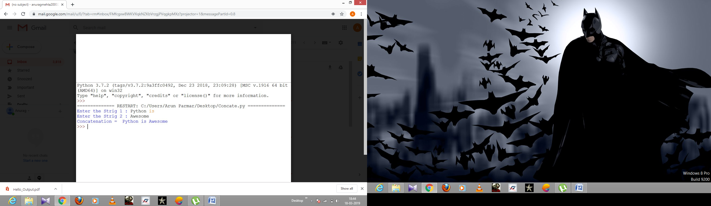

Output

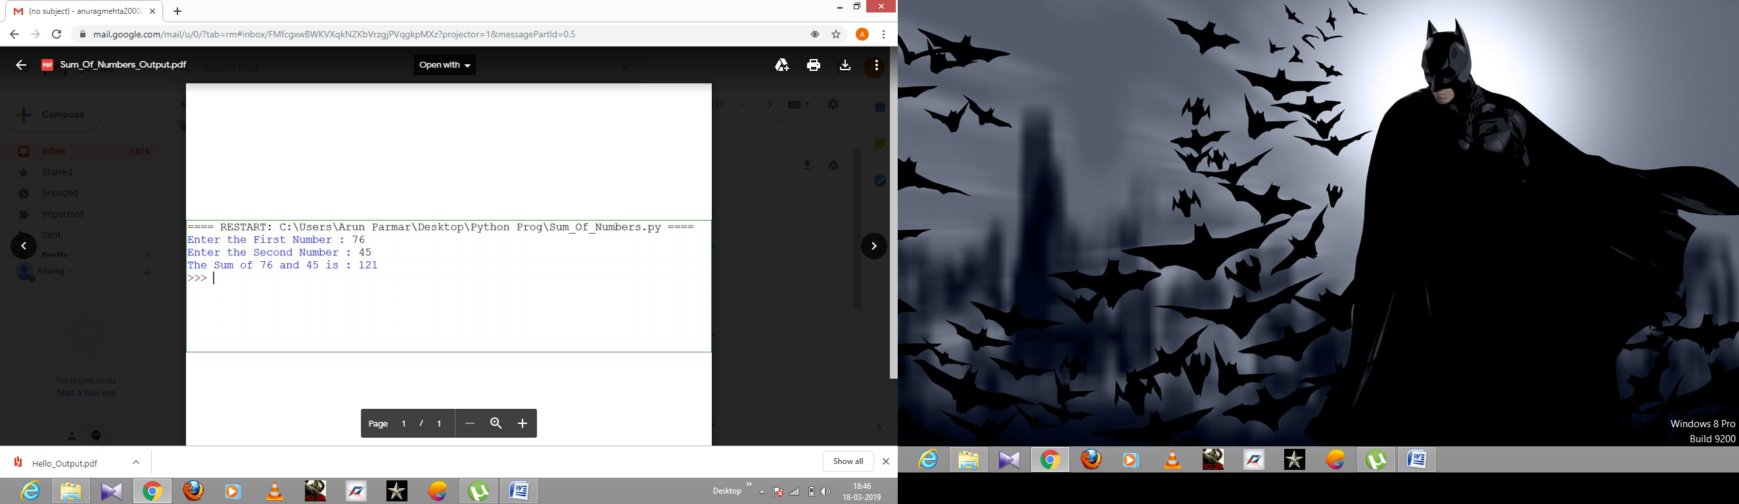

Output

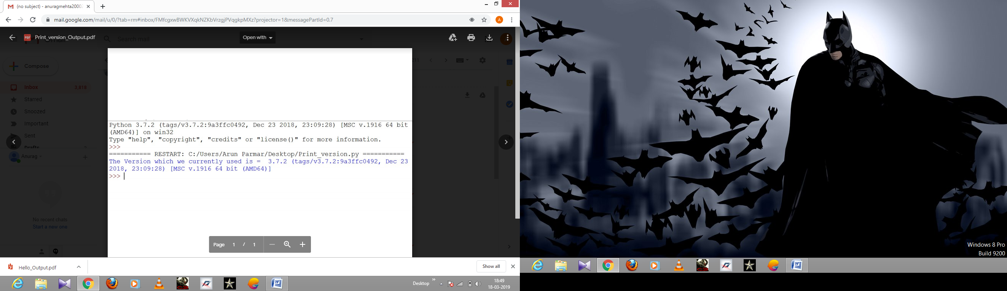

Output

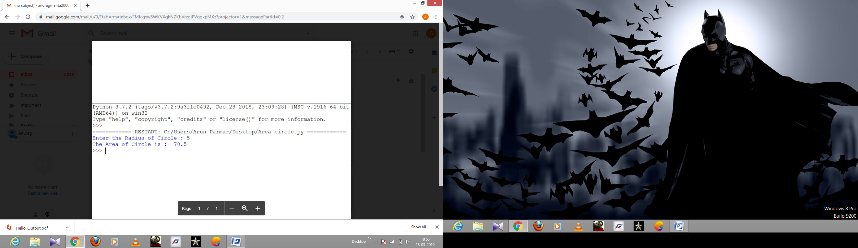

Output

Enter the First Name : Anurag

Enter the Last Name : Mehta

Mehta Anurag

>>>>

Output

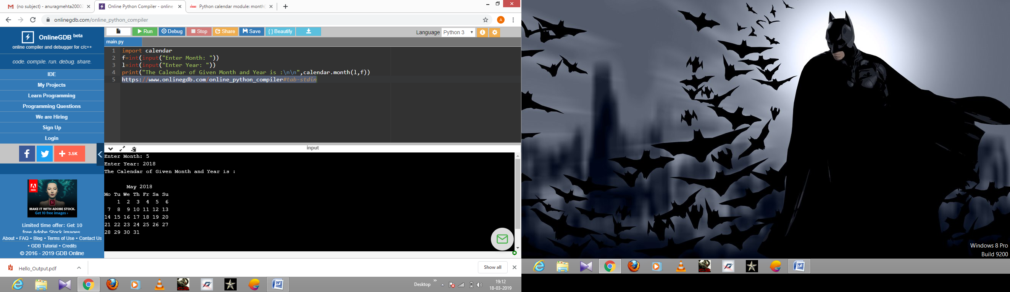

Output

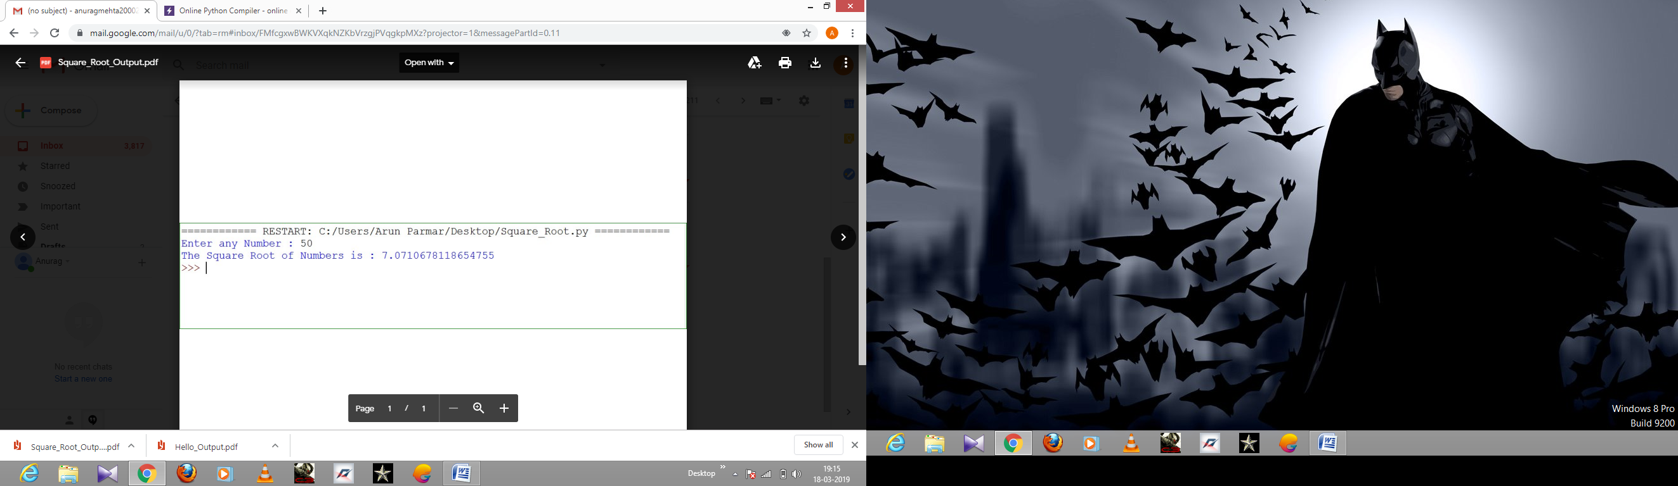

Output

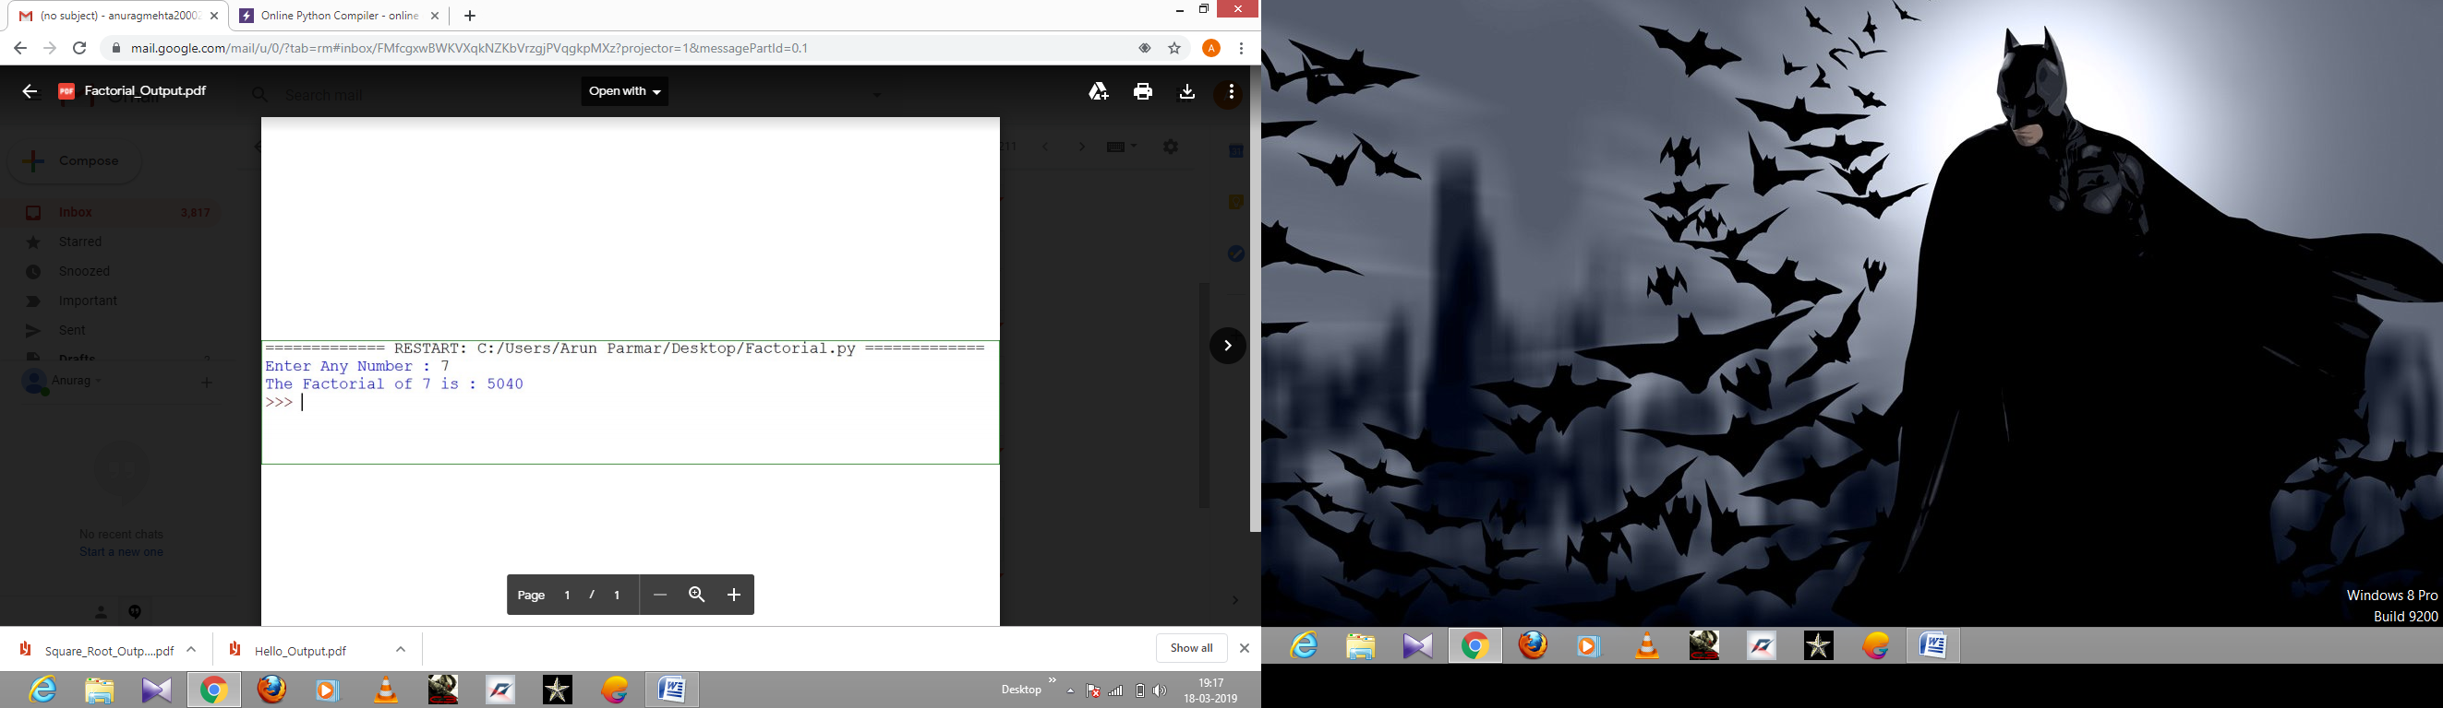

Output

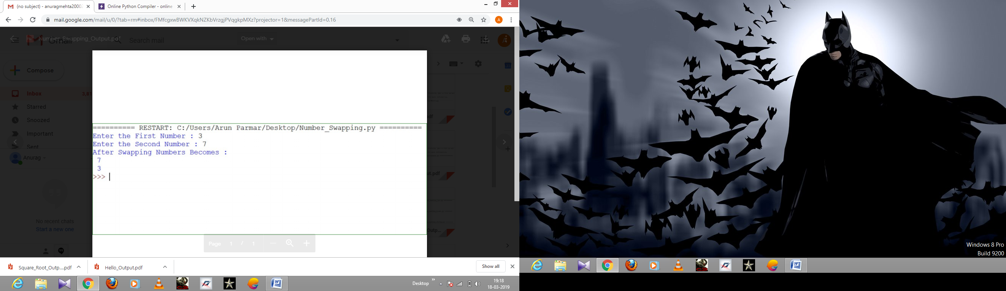

Output

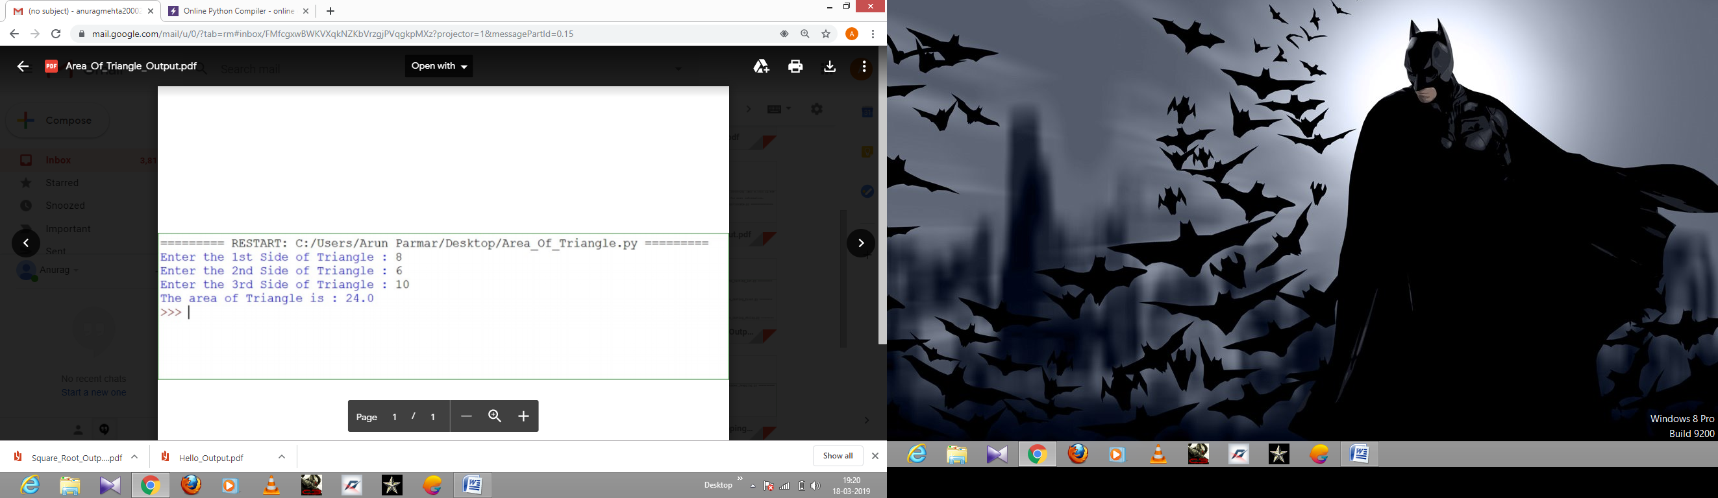

Output

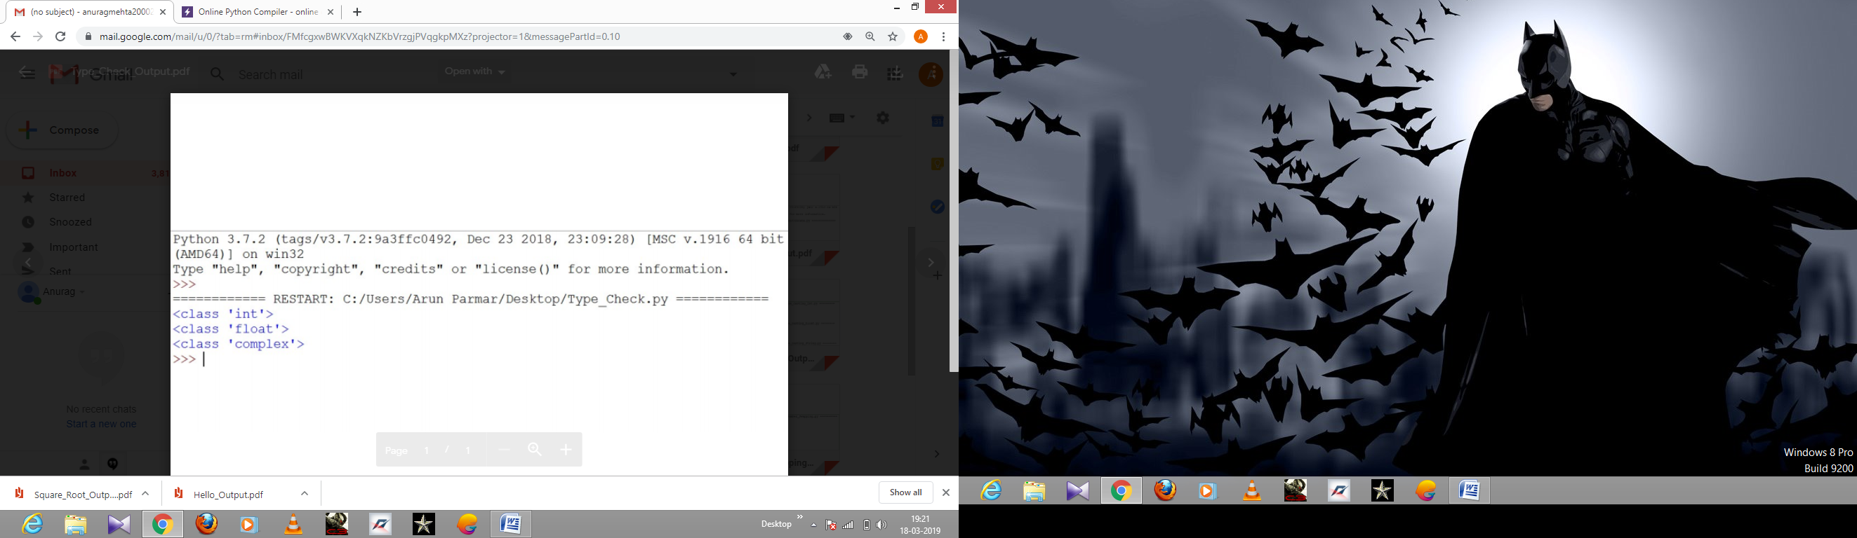

Output

2

2

2

3.4

>>>>

2.0

2.4

3.0

3.4

>>>>

2

2.4

3

3.4

>>>>

Output

Enter String : Anurag Mehta

The First character is : A

>>>>

Enter String : Hello World

The characters from index 2 to 5 are : llo

>>>>

Enter String: Hello World

Hello World

>>>>

Enter String : Hello World

String in lower case : hello world

>>>>

Enter String : hello World

String in upper case : HELLO WORLD

>>>>

Enter String : Hello World

String after replacing H : Jello World

>>>>

Enter Your Name : Anurag Mehta

Hello Anurag Mehta

>>>>

Output

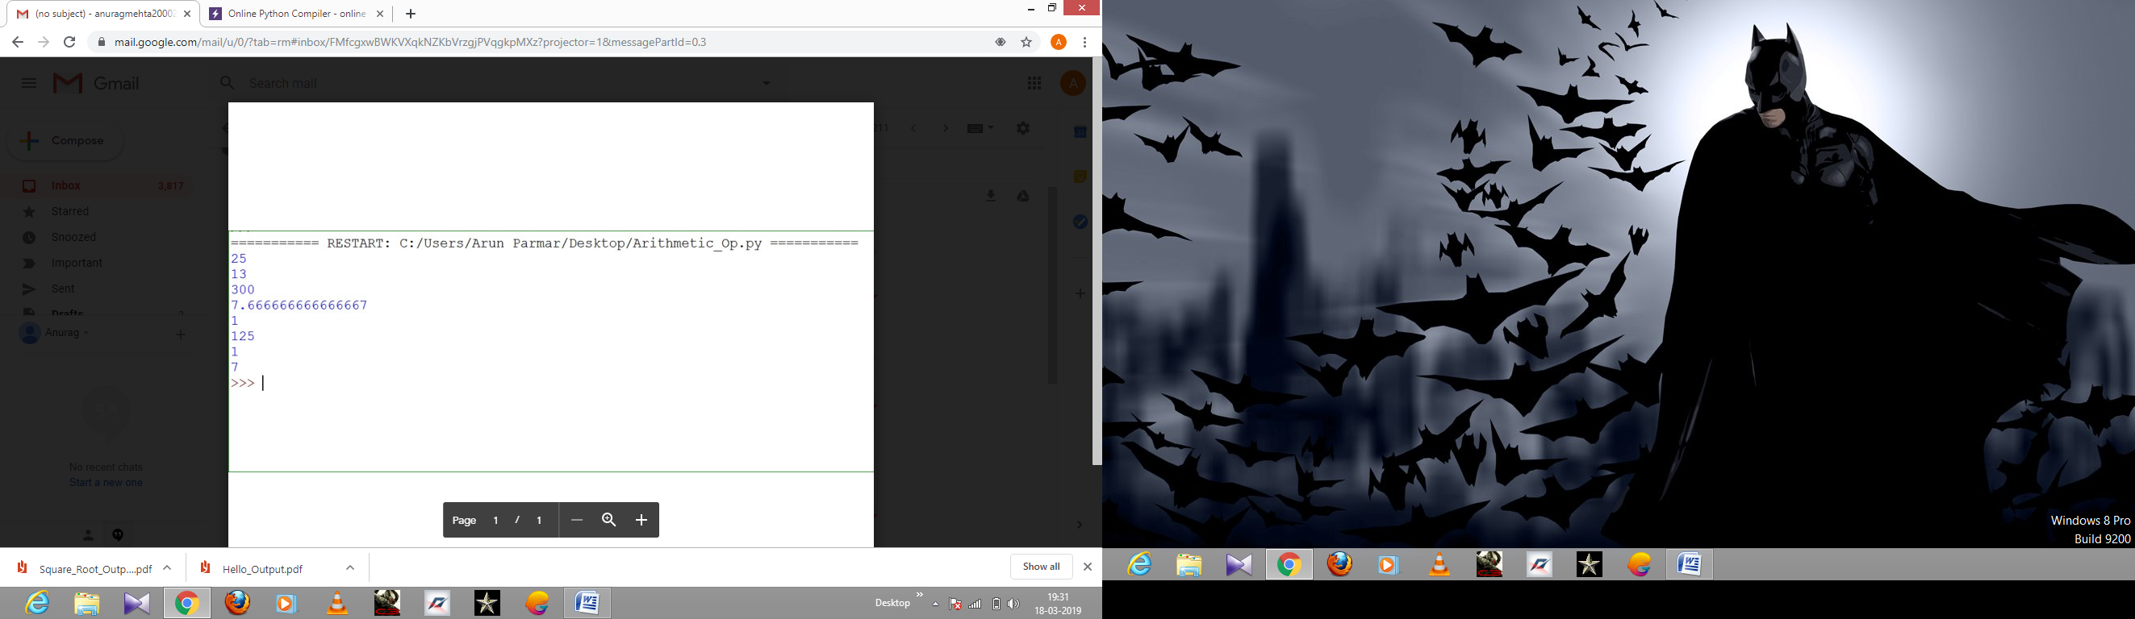

Output

